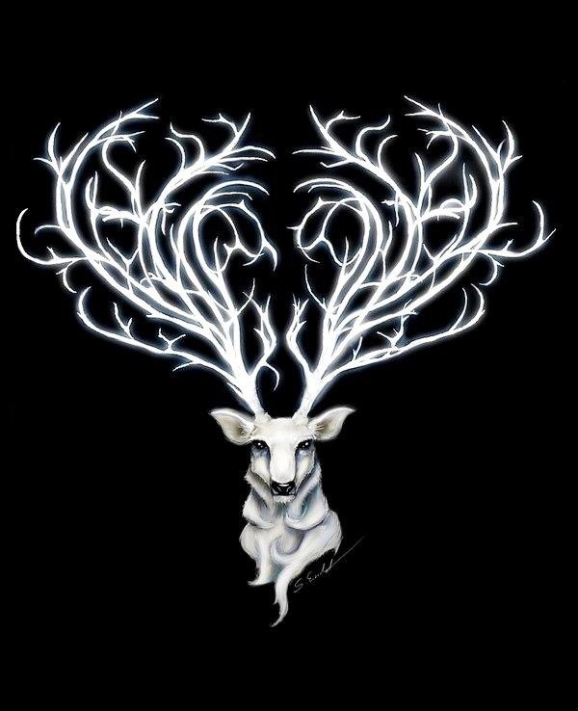
www.thewhitehartinnllandeilo.co.uk
CHRISTMAS AT
The White Hart 2019

2 COURSE DINNER with Teas & Coffees - £ 19
3 COURSE DINNER with Teas & Coffees - £22

CHRISTMAS CABARET 3 COURSE DINNER £27

CHRISTMAS CABARET EVENINGS
RESERVED FESTIVE TABLES COURSE FESTIVE MENU
PROFESSIONAL CABARET ACT WITH ‘STEVIE J’
LATE NIGHT DISCO UNTIL 1AM

SATURDAY EVENINGS throughout DEC

THE WHITE HART
LLANDEILO
Inn, Restaurant & Function Venue
Carmarthen Road
Llandeilo
SA19 6RS
Tel: 01558 823419 contact@whitehartinnwales.co.uk
£5 per person non-refundable deposit on confirmation. No pre-order required. Final numbers 24 hours prior to party which will confirm final payment.

PARTY ORGANISER GOES FREE WITH 25 GUESTS
WHITE HART LLANDEILO

Christmas Lunch &
Dinner Menu

TO START
Chef’s Homemade Soup of the day
Traditional Prawn Cocktail
Creamy Garlic Mushrooms
Honeydew Melon with a raspberry coulis

FOR MAINS
Silverside of Beef & Yorkshire Pudding
Roast Pembrokeshire Turkey & Cranberry and Sage Stuffing
Pan Fried Sea Bass Fillet in a Prawn & Lemon Butter
Served with 4 fresh seasonal vegetables, roasted & mashed potatoes and thick homemade gravy

TO FINISH
Traditional Christmas Pudding & Brandy Sauce
Chocolate Profiteroles with Fresh Cream
Homemade Cheesecake
Warm Lemon Meringue Pie

TEAS AND COFFEES

2 COURSE OPTIONS MUST BE:
EITHER STARTER AND MAIN OR MAIN AND DESSERT

