THE WHITE HART LLANDEILO
2019
DINNER PARTIES
‘ Many Thanks for your Enquiry’
- We can provide a choice of two private function suites with your own bar and disabled access throughout.
- Entertainment can be arranged
- Cloths and napkins in choice of colour
- No Pre orders Required
- Large free Car Park
- Reduced Room Rates
- Menus can be altered to suit budgets and taste
- Professionally served to tables in private dining room
- We can also provide hot/cold buffets or choices from our regular menu

‘TRADITIONAL DINNER PACKAGE’
£22 - 3 Course, £18 – 2 Course, £15 – 1 Course
Chefs Homemade Soup with a Bread Roll and Butter
Fresh Honeydew Melon with a Raspberry Coulis
Traditional Prawn Cocktail
Creamy Garlic Mushrooms
Liver & Pork Pate with a Caramalised Onion Chutney

Roast Pork
Pembrokeshire Turkey
Silverside of Beef
Sea Bass in a Prawn & Lemon Butter
Cranberry & Brie Wellington
All served with a choice of 3 fresh vegetables, homemade stuffing, roast potatoes and parsnips and thick homemade gravy

Homemade Cheesecake of your choice
Chocolate Profiteroles & Fresh Cream
Lemon Meringue Pie
Homemade Crumble of your choice with Custard
Individual Trifles
Fresh Fruit Salad

Teas & Coffees (included with 1, 2 or 3 Course)

CHOOSE TWO OPTIONS FROM EACH COURSE – up to 40 guests
CHOOSE THREE OPTIONS EACH COURSE – up to 100 guests
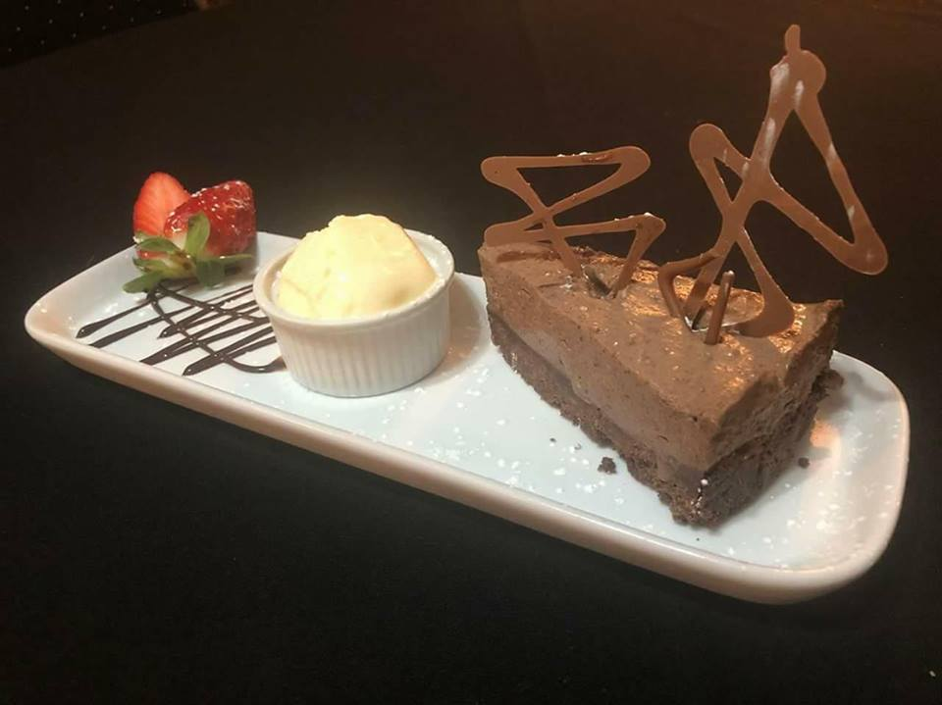

DELUXE MENU - £27 Per Person
Chefs Homemade Soup of choice with a Bread Roll
Welsh Cockles, lavabread & Bacon in a creamy sauce
Stuffed Portobello Mushroom in a Garlic Sauce
Beer Battered Chicken Breast Goujons
Duck Wings in a Hoi sin Sauce

Parma Ham Wrapped Chicken with Fresh Crispy Leeks
Pan Fried Sea Bass Fillets with a Butter Lemon Sauce
8 oz Lamb Rump Steak with Seasonal Vegetables
Pork Medallions with a Honey & Mustard Jus
All served with a choice of Potato

Raspberry & White Chocolate Meringue Roulade
Crème Brulee with a Homemade Shortbread Biscuit
Prosecco & Strawberry Truffle
Ice-Cream Sundae (of choice)

Teas & Coffees with mints
